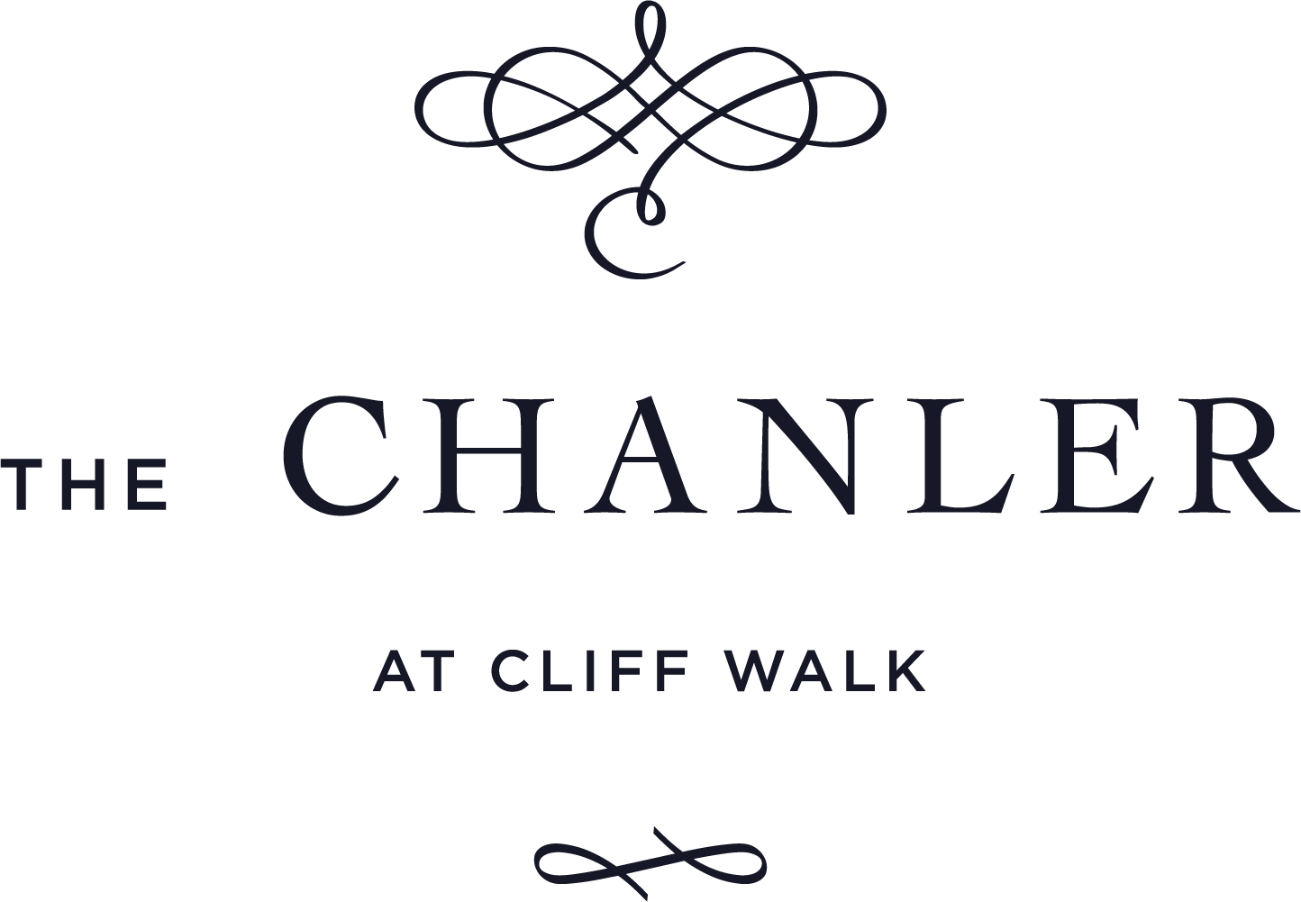

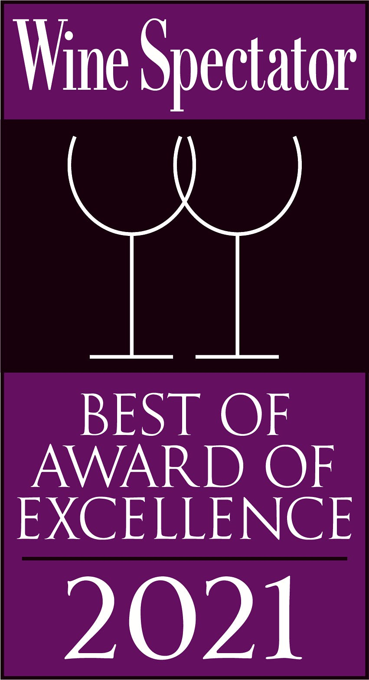

TABLE OF CONTENTS

 | PAGE
Signature Drinks | 3
Wines By the Glass / Non-Alcoholic Signature Drinks | 4 - 6
Champagne & Sparkling | 10 - 11
White Wines | 12 - 15
Rosé Wines | 15
Red Wines | 16 - 22
Beer Selections | 23
Liquor Selections | 24
Rare and Unique Offerings | 25
Cognac / Calvados / Armagnacs | 26
Dessert Wines & Digestifs | 27

SIGNATURE DRINKS

French 1908 | 19
sparkling wine, empress gin, lemon, sugar
Chanler Daiquiri | 17
eclipse rum, lime juice, powdered sugar, crushed ice- just like William Chanler used to make…
Miracles | 19
casamigos blanco & mezcal, campari, carpana antica, ramazotti, large rocks
Nutty Bean | 16
van gogh vanilla vodka, chocolate liqueur, hazelnut, touch of cream, chocolate espresso bean
NPT Trolley | 18
tito’s, pampelmousse liqueur, elderflower, grapefruit, lime juice
High Horse | 17
maker’s mark, johnnie walker, domaine canton ginger, honey-ginger syrup
*The Sour One | 18
knob creek rye, lemon, egg white
*The Cliff Walk | 18
maker’s mark bourbon, maple honey syrup, apple-yuzu nectar, black walnut bitters
Pear Martini | 19
grey goose pear, amaretto disaronno, pear nectar, cinnamon, lemon juice
The Fig Tree | 18
black fig vodka, amaro dell etna, lemon juice, thyme sugar syrup, apricot nectar
*Contain nut or egg products. May be food allergy sensitive.

ALMOST COCKTAILS

Easton Refresher | 18
blackcurrant nectar, lemon juice, thyme sugar syrup, ginger beer, soda water
Floralia | 17
apple-yuzu juice, passion fruit purée, lime juice, hibiscus syrup

WINES BY THE GLASS

CHAMPAGNE AND SPARKLING
CHAMPAGNE |  |  | Glass | Bottle
n/v | Moët and Chandon, Impérial, Brut, Épernay |  | 32 | 110
SPARKLING WINE
n/v |  | Domaine Chandon, Rosé, Napa Valley, California | 18 | 63
n/v |  | Canella, D.O.C.G., Prosecco di Conegliano, Italy | 13 | 44

WHITE WINES
SAUVIGNON BLANC
2020 | Domaine Serge LaPorte, Sancerre |  | 16 |  | 66
2020 | Spy Valley, Marlborough |  | 14 |  | 46
CHARDONNAY
2018 | Grgich Hills, Napa Valley |  | 20 |  | 75
2018 | Chateau Ste. Michelle, Canoe Ridge, Columbia Valley |  | 15 |  | 60
2020 | Louis Jadot, Pouilly-Fuissé, Burgundy |  | 18 |  | 72
PINOT GRIGIO - ITALY
2020 | La Rocca, Collio |  | 13 |  | 42
WHITE BLEND
2018 |  | Channing Daughters, Vino Blanco, Long Island, New York |  | 13 |  | 40

ROSÉ WINES
2020 | Château Beaulieu, Coteaux d’Aix-en-Provence | 15 | 49
2020 | Couly-Dutheil, Rene Couly, Chinon | 16 | 58
2020 | Sokol Blosser, Oregon | 13 | 48

RED WINES
 |  | 6 oz | Bottle
PINOT NOIR - CALIFORNIA
2019 | Cuvaison, Carneros, Napa Valley | 19 | 75
2019 | Belle Glos, Clark & Telephone Vineyard, Santa Maria Valley | 20 | 80
2020 | Domaine Billard, Saint-Romain, La Perriere | 16 | 65
MERLOT - WASHINGTON
2017 | Chateau Ste. Michelle, Indian Wells, Columbia Valley | 16 | 65
BORDEAUX - FRANCE
2017 | Château Mirambeau Papin, Bordeaux Supérieur | 16 | 53

CABERNET SAUVIGNON - CALIFORNIA
2017 | Hall, Napa Valley | 25 | 105
2018 | Justin, Paso Robles | 17 | 67
MALBEC - ARGENTINA
2018 | Catena, Mendoza | 15 | 52
ZINFANDEL - CALIFORNIA
2019 | Ridge Estate, Sonoma County | 13 | 50

WINES BY THE HALF BOTTLE

 | CHAMPAGNE AND SPARKLING
Bin | CHAMPAGNE - FRANCE
10 | n/v | Billecart-Salmon Brut Rosé, Mareuil-sur-Aÿ | 90
11 | n/v | Krug, Grand Cuvée, Reims | 260
12 | n/v | Ruinart, Blanc de Blancs, Reims | 95
13 | n/v | Taittinger, La Française Brut, Reims | 58
 | WHITE WINES
 | CHARDONNAY
15 | 2017 | Steele, Chardonnay, Steele Cuvée, California | 30
16 | 2016 | Louis Jadot, Chardonnay, Mâcon-Villages, Burgundy | 19
17 | 2018 | Chateau Ste. Michelle, Chardonnay, Columbia Valley | 21
 | SAUVIGNON BLANC - CALIFORNIA
18 | 2018 | Duckhorn Vineyards, Sauvignon Blanc, Napa Valley | 25
 | RIESLING - FRANCE
19 | 2018 | Hugel Riesling, Alsace | 33
 | PINOT BLANC - CALIFORNIA
20 | 2015 | Robert Sinskey Vineyards, Pinot Blanc, Los Carneros | 58

WINES BY THE GLASS

WINES BY THE HALF BOTTLE

 | RED WINES
Bin | CABERNET SAUVIGNON - CALIFORNIA
30 | 2018 | Hess, Allomi, Cabernet Sauvignon, Napa Valley | 32
31 | 2016 | Mayacamas Vineyards, Cabernet Sauvignon, Mt. Veeder, Napa Valley | 125
 | BORDEAUX - FRANCE
33 | 2016 | Château Haut-Ségottes, St. Émilion, Grand Cru | 33
 | BEAUJOLAIS - FRANCE
35 | 2017 | Louis Jadot, Gamay, Beaujolais-Villages | 15
 | POMMARD - FRANCE
40 | 2018 | Louis Jadot, Burgundy | 68
 | BRUNELLO - ITALY
41 | 2015 | Col d’Orcia, D.O.C.G., Brunello di Montalcino, Tuscany | 65
 | MERLOT - CALIFORNIA
45 | 2018 | Duckhorn Vineyards, Merlot, Napa Valley | 51
46 | 2015 | Rutherford Hill, Merlot, Napa Valley | 34
 | PINOT NOIR - OREGON
49 | 2018 | King Estate | 25

OUR FEATURED CHAMPAGNES & SPARKLINGS

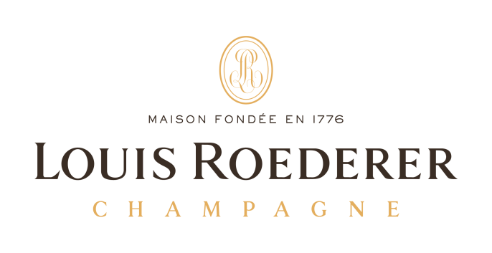

Bin
101 | 2008 | Louis Roederer, Cristal | 460
102 | 20013 | Pol Roger, Blanc de Blancs | 250
103 | 2007 | Louis Roederer, Cristal Rosé | 799

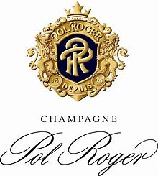

105 | n/v | Pol Roger, White Foil, Brut | 120
106 | 2013 | Pol Roger, Blanc de Blancs | 250
107 | 2006 | Pol Roger Cuvée, Sir Winston Churchill | 575

OUR FEATURED CHAMPAGNES & SPARKLINGS

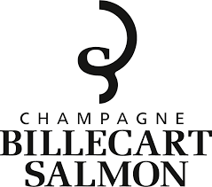

Bin
108 | 2006 | Billecart-Salmon, Cuvée Nicolas François Billecart, Brut, Mareuil-sur-Aÿ | 392
109 | m/v | Billecart-Salmon, Cuvée Sous Bois, Brut, Mareuil-sur-Aÿ | 180
 |  | This unique cuvée, which is entirely in oak, is composed of the three Chamenois grape varieties. It masters the art of blending by renewing the ancestral spirit of the original champagnes.

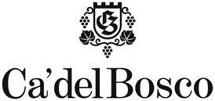

110 | 2011 | Ca’ del Bosco, Cuvée, Annamaria Clementi | 187
111 | 2011 | Ca’ del Bosco, Cuvée, Annamaria Clementi, Rosé | 227
112 | n/v | Ca’ del Bosco, Cuvée Prestige | 70
113 | n/v | Ca’ del Bosco, Cuvée Prestige, Rosé | 125
114 | n/v | Ca’ del Bosco, Torresella Prosecco | 55
115 | 2016 | Ca’ del Bosco, Vintage Collection, Dosage Zero | 135

CHAMPAGNE

Bin | ÉPERNAY
117 | 2012 | Dom Pérignon, Brut | 495
118 | 2011 | Pérrier-Jouët, Belle Epoque | 352
119 | n/v | Moët & Chandon, Impérial, Brut | 110
 | MAREUIL-SUR-AŸ
121 | n/v | Bollinger Special Cuvée | 190
122 | n/v | Gosset, Grand Réserve Brut | 130
 | REIMS
125 | 2007 | Charles de Cazanove Stradivarius, Brut | 115
126 | n/v | G.H. Mumm, Cordon Rouge | 109
127 | n/v | Krug, Grande Cuvée Brut, | 420
128 | n/v | Piper-Heidsieck, Brut | 134
129 | n/v | Ruinart, Blanc de Blancs, Brut | 220
130 | n/v | Taittinger, La Française, Brut | 98
131 | 2008 | Taittinger, Comtes de Champagne, Blanc de Blanc | 470
132 | n/v | Veuve Clicquot, Yellow Label, Brut | 108
133 | 2008 | Veuve Clicquot, La Grande Dame | 410
ROSÉ OF CHAMPAGNE

Bin | CHOUILLY
140 | n/v | Nicolas Feuillatte, Brut | 107
141 | 2005 | Nicolas Feuillatte, Cuvée Palmes d'Or | 414
 | ÉPERNAY
143 | 2006 | Dom Pérignon, Brut | 895
 | MAREUIL-SUR-AŸ
144 | n/v | Billecart-Salmon, Brut | 185
145 | n/v | Bollinger, Brut | 220
 | REIMS
147 | n/v | Ruinart, Brut | 220
148 | n/v | Taittinger, Prestige Rosé | 164
149 | 2006 | Taittinger, Comtes de Champagne Rosé | 475
150 | n/v | Veuve Clicquot, Brut | 161
151 | 2005 | Veuve Clicquot, La Grande Dame, Brut | 540

SPARKLING WINE

 |  | SPARKLING – U.S.A.
155 | n/v |  | Domaine Chandon, Brut, Napa Valley | 47
156 | n/v |  | Roederer Estate Brut, Anderson Valley | 63
157 | n/v |  | Roederer Estate, Brut Rosé, Anderson Valley | 71
 |  | SPARKLING - ITALY
158 | n/v
159 | n/v
160 | n/v
161

CHARDONNAY

Bin |  | CALIFORNIA
170 |  | 2012 |  | Albert Bichot, Domaine du Pavillon, Meursault |  | 125
172 |  | 2016 |  | Beringer, Private Reserve, Napa Valley |  | 90
173 |  | 2019 |  | Cakebread, Napa Valley |  | 86
174 |  | 2013 |  | Carte Blanche, Sonoma Coast |  | 123
175 |  | 2017 |  | Cuvaison, Carneros, Napa Valley |  | 66
176 |  | 2018 |  | HdV, Hyde Vineyard, Carneros, Napa Valley |  | 149
178 |  | 2018 |  | Far Niente, Napa Valley |  | 150
179 |  | 2014 |  | Jackson Estate, Santa Maria Valley, Santa Barbara County |  | 49
180 |  | 2016 |  | Jordan, Russian River Valley, Sonoma County |  | 76
181 |  | 2018 |  | Kistler, Les Noisetiers, Sonoma Coast |  | 123
182 |  | 2016 |  | Merryvale, Carneros, Napa Valley |  | 75
183 |  | 2015 |  | Ramey, Ritchie Vineyard, Russian River Valley, Sonoma Valley |  | 139
184 |  | 2013 |  | Robert Mondavi, Reserve, Carneros, Napa Valley |  | 83
185 |  | 2011 |  | Sanford, Santa Rita Hills, Santa Barbara County |  | 67
188 |  | 2018 |  | Shafer Red Shoulder Ranch, Carneros, Napa Valley |  | 122
189 |  | 2020 |  | Silverado Vineyards, Carneros, Napa Valley |  | 82
190 |  | 2018 |  | Sonoma-Cutrer, Russian River Ranches, Sonoma Coast |  | 48
 | 270 |  | 2019 |  | Sonoma-Cutrer, Les Pierres, Chardonnay |  | 82
 |  | OREGON
191 |  | 2015 |  | Domaine Serene, Evanstad Reserve, Dundee Hills |  | 139
 |  | ARGENTINA
192 |  | 2012 |  | Catena, Alta, Mendoza |  | 74
 |  | FRANCE
193 |  | 2018 |  | Louis Jadot, Chassagne-Montrachet |  | 119
194 |  | 2016 |  | Louis Latour, Grand Cru, Corton-Charlemagne |  | 310
195 |  | 2019 |  | Louis Latour, Chablis |  | 62
 |  | ITALY
196 |  | 2016 |  | Ca’ del Bosco, Chardonnay |  | 155

SAUVIGNON BLANC

Bin | CALIFORNIA
200 | 2019 | Cakebread, Napa Valley | 59
201 | 2017 | Grgich Hills, Essence, Miljenko’s Grgich Selection, Napa Valley | 129
202 | 2017 | Hall, Napa Valley | 57
203 | 2019 | Honig, Napa Valley | 40
204 | 2019 | Merry Edwards, Russian River Valley, Sonoma County | 92
205 | 2015 | Provenance, Rutherford, Napa Valley | 54
206 | 2018 | Spottswoode, Sonoma County/Napa County | 85
207 | 2019 | St. Supéry Estate Vineyards, Dollarhide Estate, Napa Valley | 58
 | FRANCE
210 | 2018 | Chateau Carbonnieux, Pessac-Léognan, Grand Cru | 121
211 | 2019 | Claude Riffault, Les Boucauds, Sancerre | 59
212 | 2018 | Marc Deschamps, Les Champs de Cri, Pouilly-Fumé | 60
213 | 2020 | Pascal Jolivet, Sancerre | 63
 | NEW ZEALAND
215 | 2019 | Cloudy Bay, Marlborough | 81
216 | 2019 | Craggy Range, Te Muna Road Vineyard, Martinborough | 47
217 | 2016 | Kim Crawford, Marlborough | 35
218 | 2019 | Loveblock by Kim Crawford, Marlborough | 55
219 | 2017 | Villa Maria, Cellar Selection, Marlborough | 44

PINOT GRIGIO

Bin | FRANCE
230 | 2012 | Trimbach, Reserve, Alsace | 56
 | ITALY
231 | 2018 | Bortoluzzi, Friuli-Venezia Giulia | 38
232 | 2018 | Livio Felluga, Collio | 58
233 | 2019 | Santa Margherita, Valdadige | 52
RIESLING

 | FRANCE
235 | 2018 | Domaines Schlumberger, Dry Riesling, Alsace | 60
236 | 2011 | Trimbach, Cuvée Frédéric Émile, Alsace | 180
 | GERMANY
238 | 2018 | Dönnhoff, Spätlese, Norheimer Kirschheck, Nahe | 76
239 | 2016 | J.J. Prum, Wehlener Sonnenuhr Spätlese, Mosel | 101
 | WASHINGTON STATE
246 | 2017 | Chateau Ste. Michelle, Eroica, Columbia Valley | 49

INTERESTING WHITES

Bin | AUSTRIA
250 | 2016 |  | Domäne Wachau, Grüner Veltliner, Terrasen Federspiel, Wachau | 45
 | FRANCE
255 | 2016 | Vermentino, Domaine Bila-Haut, Occultum Lapidem |  | 85
256 | 2018 | Bordeaux Blend, Chateau Picque Caillou, Pessac-Léognan |  | 98
257 | 2017 | Chenin Blanc, Couly-Dutheil, Les Chanteaux, Chinon |  | 63
 | ITALY
260 | 2018 | Vermentino, Guado al Tasso, Bolgheri |  | 60
261 | 2016 | Roero Arneis, Malvira, D.O.C.G., Piedmont |  | 43
262 | 2017 | Cortese di Gavi, Pio Cesare, Piedmont |  | 55
 | SOUTH AFRICA
265 | 2015 | Blend, Edgebaston, Honey Shale Hill, Stellenbosch |  | 39
ROSÉ

 | FRANCE
275 | 2019 | Château Miraval, Côtes de Provence | 48
276 | 2019 | Château Peyrassol, Côtes de Provence | 55
277 | 2020 | Domaines Ott By Ott, Côtes de Provence | 50
278 | 2018 | Domaine Tempier, Bandol, Provence | 78

.
PINOT NOIR

Bin | CALIFORNIA
280 | 2014 | Calera, de Villiers Vineyard, San Benito County |  |  | 87
281 | 2012 | Champ de Rêves, Anderson Valley, Mendocino County |  |  | 77
282 | 2019 | Etude, Grace Benoist Ranch, Carneros |  |  | 95
283 | 2015 | Gehricke, Los Carneros, Sonoma |  |  | 105
284 | 2013 | Hartford Court, Land’s Edge Vineyard, Sonoma Coast |  |  | 95
285 | 2017 | Hanzell, Sonoma Valley, Sonoma County |  |  | 200
286 | 2017 | J. Lohr, Fog’s Reach, Arroyo Seco, Monterey County |  |  | 69
287 | 2017 | Merry Edwards, Russian River Valley |  |  | 131
88 | 2016 | Paul Hobbs, Russian River Valley |  |  | 145
289 | 2014 | Robert Sinskey Vineyards, Los Carneros, Napa Valley |  |  | 84
 | OREGON
290 | 2017 |  | Archery Summit, Premier Cuvée, Dundee Hills |  | 115
291 | 2018 |  | Argyle, Nuthouse, Eola-Amity Hills |  | 102
292 | 2013 |  | Domaine Serene, Evenstad Estate, Willamette Valley |  | 165
293 | 2016 |  | Erath, Estate Selection, Willamette Valley |  | 68
294 | 2016 |  | Rex Hill, Jacob-Hart Vineyard, Willamette Valley |  | 116
 | FRANCE
295 | 2019 |  |  | Domaine Faiveley, Mercurey, Grand Vin Bourgogne | 110
296 | 2019 |  |  | Joseph Drouhin, Gevrey-Chambertin, Côte de Nuits | 131
297 | 2016 |  |  | Louis Jadot, Nuits-Saint-Georges, Côte de Nuits | 119
 | NEW ZEALAND
298 | 2018 |  |  | Craggy Range, Te Muna Road Vineyard, Martinborough | 83
299 | 2009 |  |  | Villa Maria, Reserve, Marlborough | 77
 | ITALY
300 | 2016 |  |  | Ca’ del Bosco, Pinéro | 155

CABERNET SAUVIGNON

Bin | CALIFORNIA
350 | 2013 | Antica, Napa Valley | 140
351 | 2016 | Beringer, Private Reserve, Napa Valley | 249
352 | 2018 | Black Stallion Estate Winery, Napa Valley | 71
353 | 2017 | Cade, Howell Mountain, Napa Valley | 215
354 | 2013 | Carte Blanche, Napa Valley | 232
355 | 2013 | Cardinale, Napa Valley | 550
356 | 2017 | Charles Krug, Napa Valley | 88
357 | 2013 | Chappellet, Pritchard Hill, Napa Valley | 435
358 | 2017 | Darioush, Signature Series, Napa Valley | 235
359 | 2013 | Flora Springs, Rennie Reserve, St. Helena, Napa Valley | 323
360 | 2017 | Frog’s Leap, Rutherford, Napa Valley | 109
361 | 2016 | Grgich Hills, Napa Valley | 169
362 | 2010 | Guarachi Family Wines, Napa Valley | 155
363 | 2018 | Hall, Kathryn Hall, Napa Valley | 270
364 | 2018 | Hourglass, Blueline Vineyard, Napa Valley | 250
365 | 2017 | Jackson Estate, Alexander Valley, Sonoma County | 61
366 | 2018 | Jordan, Alexander Valley, Sonoma County | 121
367 | 2014 | Keenan, Spring Mountain District, Napa Valley | 220
368 | 2012 | Lokoya, Howell Mountain, Napa Valley | 681
369 | 2017 | Memento Mori, Napa Valley | 435
370 | 2013 | Paul Hobbs, Backstoffer Kalon Vineyard, Oakville | 850
371 | 2013 | Rutherford Ranch Reserve, Napa Valley | 96
372 | 2015 | Revana, Terroir Series, Napa Valley | 197
373 | 2018 | Shafer, One Point Five, Stags Leap District, Napa Valley | 202
574 | 2014 | Signorello Estate, Napa Valley | 175
375 | 2016 | Silver Oak, Napa Valley | 280
376 | 2017 | Spottswoode Estate, St. Helena, Napa Valley | 299
377 | 2014 | St. Supéry Estate, Dollarhide Estate, Napa Valley | 183
378 | 2018 | Stag’s Leap Wine Cellars, Artemis, Napa Valley | 165
379 | 2016 | Stonestreet Estate Vineyards, Alexander Valley, Sonoma County | 78
380 | 2015 | Trinchero, Mario’s Vineyard, St. Helena, Napa Valley | 140

Bin | AUSTRALIA
400 | 2016 | Penfolds, Bin 707, South Australia | 940
 | CHILE
405 | 2016 | Concha y Toro, Marques de Casa Concha, Puente Alto | 65

BORDEAUX

Bin | MARGAUX
440 | 2017 | Château Kirwan | 190
441 | 2014 | Château Palmer, Alter Ego, Margaux | 240
 | SAINT-ESTÈPHE
442 | 2013 | Château de Pez, Cru Bourgeois | 125
443 | 2018 | Château Cos d’Estournel, Grand Cru Classé | 425
444 | 2015 | Chateau Tour du Cauze | 59
 | SAINT-EMILION
445 | 2016 | Château Lassègue, Grand Cru Classé | 145
446 | 2015 | Les Cadrans de Lassègue, Grand Cru | 58
CABERNET SAUVIGNON

ZINFANDEL

 | CALIFORNIA
410 | 2018 | Bedrock Winery, Old Vine, Sonoma County | 45
411 | 2013 | Grgich Hills, Napa Valley | 92
412 | 2015 | Seghesio Family Vineyards, Old Vine, Sonoma County | 95
413 | 2019 | Ridge Estate, Sonoma County | 50

MERLOT

 | CALIFORNIA
415 | 2017 |  | Duckhorn Vineyards, Napa Valley | 94
416 | 2013 |  | Grgich Hills, Napa Valley | 108
417 | 2018 |  | Hourglass, Blueline Vineyard, Napa Valley | 140
418 | 2012 |  | Keenan, Napa Valley | 87
419 | 2014 |  | Plumpjack, Napa Valley | 125
420 | 2013 |  | Thorn, The Prisoner Wine Company, Napa Valley | 89
 | WASHINGTON STATE
422 | 2016 | Chateau Ste. Michelle, Indian Wells, Columbia Valley |  | 48

NEBBIOLO

425 | 2013 | Marchesi di Barolo, Cannubi, D.O.C.G., Barolo, Piedmont | 213
426 | 2013 | Michele Chiarlo, Tortoniano, D.O.C.G., Barolo, Piedmont | 120
427 | 2013 | Pio Cesare, Barolo, D.O.C.G., Piedmont | 171

SUPER TUSCAN

430 | 2018 | Antinori, Tignanello, IGT | 230
431 | 2016 | Gaja, Ca’Marcanda Magari, IGT, Bolgheri | 155
432 | 2016 | I Giusti & Zanza, Dulcamara, IGT | 87
433 | 2014 | Tenuta dell’Ornellaia, D.O.C. Superiore, Bolgheri | 429
434 | 2016 | Ruffino, Modus, D.O.C ., IGT | 60

PROPRIETARY REDS

Bin | CALIFORNIA
450 | 2012 | Beringer, Quantum, Blend, Napa Valley |  | 129
451 | 2016 | Blackbird, Arise, Bordeaux Blend, Napa Valley |  | 110
452 | 2014 | Charles Krug, Generations, Bordeaux Blend, Napa Valley |  | 108
453 | 2014 | Duckhorn Vineyards, The Discussion, Bordeaux Blend, Napa Valley |  | 266
454 | 2017 | Dominus Estate, Christian Moueix, Bordeaux Blend, Napa Valley |  | 690
455 | 2012 | Ferrari-Carano, PreVail, Back Forty, Alexander Valley |  | 173
456 | 2013 | Ferrari-Carano Trésor, Bordeaux Blend, Sonoma County |  | 118
457 | 2014 | Flora Springs, Trilogy, Bordeaux Blend, Napa Valley |  | 165
458 | 2015 | Harlan Family Estates, Western Hills of Oakville, California |  | 2400
459 | 2010 | Opus One, Bordeaux Blend, Napa Valley, California |  | 785
460 | 2017 | Opus One, Bordeaux Blend, Napa Valley, California |  | 725
461 | n/v | Overture by Opus One, Bordeaux Blend, Napa Valley, California |  | 256
462 | 2013 | Robert Mondavi, Maestro, Bordeaux Blend, Napa Valley, California |  | 97
463 | 2015 | Silverado Solo, Stags Leap District, California |  | 240
464 | 2018 | Stags’ Leap Winery, The Investor, Blend, Napa Valley |  | 114
465 | 2018 | The Prisoner Wine Company, The Prisoner, Blend, Napa Valley, California |  | 95
 | ARGENTINA
470 | 2012 | Cheval des Andes, Blend, Mendoza, Argentina |  |  | 239
 | FRANCE
480 | 2006 |  | Château Mouton Rothschild, Premier Cru Classé de la region de Bordeaux |  | 1750
580 | 2007 |  | Chêne Bleu, Abélard, Grenache/Syrah, Vins de Pays de Vaucluse |  | 212
581 | 2007 |  | Chêne Bleu, Héloïse, Grenache/Syrah/Viognier, Vins de Pays de Vaucluse |  | 212
582 | 2015 |  | Domaine De Bila-Haut RI Rectifcando Invenies, Michel Chapoutier |  | 299

SYRAH & SYRAH BLENDS

Bin | CALIFORNIA
600 | 2016 | Dueling Pistols, Dueling Varietal, Petite-Sirah, Cabernet, Paso Robles | 99
601 | 2016 | Stags’ Leap Winery, Petite Sirah, Napa Valley | 93
602 | 2013 | Hawks Butte, Syrah, Yorkville Highland | 85
 | WASHINGTON STATE
605 | 2016 | Tenet, Pundit, Syrah, Columbia Valley, Washington | 60
INTERESTING REDS
 | ARGENTINA
611 | 2015 | Catena Zapata, La Consulta, Malbec, Mendoza, Argentina | 115
 | FRANCE
621 | 2016 | Bila-Haut, Occultum Lapidem, Pessac-Léognan | 60
 | ITALY
631 | 2015 | Castello Banfi, Sangiovese Grosso, Brunello di Montalcino, Tuscany | 158
632 | 2017 | Ca’ del Bosco, Maurizio Zanella, Bordeaux Blend | 155
633 | 2013 | Cesari, Il Bosco, Amarone della Valpolicella | 162
634 | 2016 | Fuligni, D.O.C.G., Brunello di Montalcino, Tuscany | 166
 | 2015 | Marchese Antinori, Sangiovese, Chianti Classico Riserva, Tuscany | 72
 | SPAIN
641 | 2008 | Numanthia, Termanthia, Tinta de Toro, Toro, Spain | 430
642 | 2018 | Chapillon Siendra, Merlot, Garnacha, Shiraz/Syrah, Cabernet Sauvignon | 40
645 | BULGARIA
 | 2015 | Petit Enira, Red Wine, Thracian Lowlands, Ognianovo Village | 45

BEERS

ALE - LOCAL
Rhode Trip, Pale Ale, Newport, R.I. | 9
Whalers, The Rise American Pale Ale, R.I. | 8
Captain’s Daughter, Double IPA, Gray Sail Brewing, Westerly, R.I. | 10
Flying Jenny, Extra Pale Ale, Gray Sail Brewing, Westerly, R.I. | 8
Old Brown Dog, Brown Ale, Smuttynose Brewing Co., Portsmouth, N.H. | 8
ALE - IMPORTED
Gulden Draak, Dark Triple, Ertvelde, East Flanders, Belgium, 10.5% ABV | 12
Orval Trappist Ale, Villers-devant-Orval, Belgium, 6.2% ABV | 13
LAGERS - DOMESTIC
Bud Light, St. Louis, Missouri, 4.2% ABV | 7
Budweiser, St. Louis, Missouri, 5.0% ABV | 7
LAGERS - IMPORTED
Amstel Light, Zoeterwoude, Netherlands, 3.5% ABV | 8
Ayinger Celebrator Dopplebock, Aying, Bavaria, Germany, 6.7% ABV | 11
Heineken, Amsterdam, Netherlands, 5.0% ABV | 8
Modelo, Mexico City, Mexico, 5.5% ABV | 8
Stella Artois, Leuven, Belgium, 5.2% ABV | 8
GLUTEN-FREE LAGER
Omission Beer Company, Portsmouth, New Hampshire, 4.6% ABV | 8
NON-ALCOHOLIC
Buckler, Zoeterwoude, Netherlands | 6
St. Pauli, Bremen, Germany | 6
HARD CIDER
Woodchuck Pear, Middlebury, Vermont | 7

SCOTCHES

HIGHLANDS | (1 ½ oz pour)
Glenmorangie 10 year, Northern Highlands | 19
Glenmorangie 18 year, Northern Highlands | 41
Glenmorangie Nectar D’Or, Northern Highlands | 26
Oban 14 year, Western Highlands | 16
SPEYSIDE
Aberlour 12 year | 15
Balvenie Doublewood 12 years | 22
Cragganmore 12 year | 15
Glenfiddich 21 year | 42
Glenlivet 18 year | 35
Glenlivet French Oak Reserve 15 year | 23
Macallan 12 year | 18
ISLAY
Ardbeg 10 year | 16
Lagavulin 16 year | 22
Laphroaig 10 year | 15
ISLE OF SKYE
Talisker 10 year | 18
LOWLANDS
Glenkinchie 12 year | 16

BOURBONS

SMALL BATCH | (1 ½ oz pour)
Basil Hayden’s 8 Years Old | 16
Bib & Tucker 6 Years Old Batch Number 019 | 16
Knob Creek 9 Years Old | 15
Maker’s Mark | 15
Masterson’s 10 years | 24
Woodford Reserve | 16
RARE AND UNIQUE

SCOTCH | (1 ½ oz pour)
Macallan 25 year | 290
A flavor explosion of fruit, vanilla and wood smoke
WHISKEY
Amador, Malt Whiskey | 26
Blend of straight malt and hop-flavored whiskey, Napa, California

COGNAC

 | (1 ½ oz pour)
Courvoisier V.S.O.P. | 19
Courvoisier X.O. | 37
Hennessy V.S.O.P. Privilege | 26
Hennessy X.O. | 55
Hennessy Paradis Imperial | 235
Hine X.O. Antique | 40
Martell X.O. | 32
Remy Martin V.S.O. P. | 19
Remy Martin V.S.O. P. | 39

REMY MARTIN LOUIS XIII

Louis XIII cognac is produced in the Grande Champagne region of Cognac, from the growing of the grapes to the distillation and aging of the eaux-de-vie. The final blend is composed of up to 1,200 individual eaux-de-vie from Grande Champagne vineyards, ranging from at least
40 years to 100 years in age.

Aficionado 0.5 oz | 150.
Connoisseur 1.0 oz | 300.
For the King 1.5 oz | 450.
For the Genius 2.0 oz | 600.

DESSERT WINES BY THE GLASS

 | (2 ½ oz pour)
2015 Haut Charmes, Sauternes, France | 21
2016 Newport Vineyards Vidal Blanc Ice Wine | 19

DESSERT WINES BOTTLES

2015 Haut Charmes, Sauternes, France (375 ml.) | 95
2011 Dolce, Napa Valley (375 ml.) | 146
2019 Newport Vineyards, Vidal Blanc, Ice Wine (375 ml.) | 70
PORT BY THE GLASS

 | (2 ½ oz pour)
Cockburn’s 10 Year Tawny | 14
Ferreira 10 Year Tawny Quinta do Porto | 14
Ferreira 20 Year Tawny Duque de Bragança | 18
Dow’s Forty Year Tawny | 36

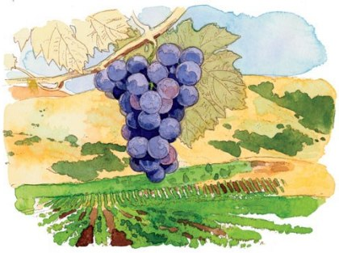
Cgigs

